scanning_ar_grey_photos.docx

TJH 19,20,22,28-JUL-23

**Scanning grey photos on Brother DCP-197C**

see next page

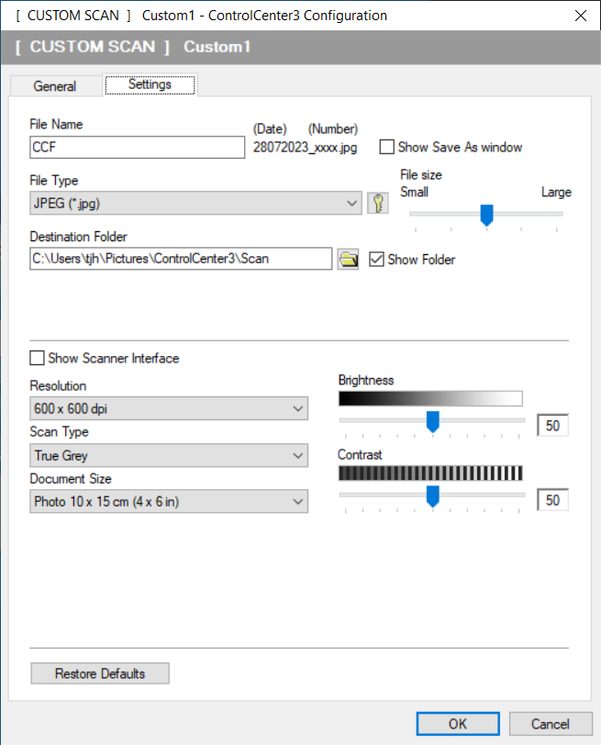

True Grey 375 KB

Grey ( Error Diffusion ) 443 KB

On my screen I can't spot the difference.

<https://support.brother.com/g/s/id/htmldoc/mfc/cv_mfc8890dw/us/html/sug/chapter9_1_4.html>

|  |  |
| --- | --- |
| • | Gray (Error Diffusion)  Use for photographic images or graphics. (Error Diffusion is a method for creating simulated gray images without using true gray dots. Black dots are put in a specific pattern to give the gray appearance.) |
| • | True Gray  Use for photographic images or graphics. This mode is more exact because it uses up to 256 shades of gray. |

<https://en.wikipedia.org/wiki/Error_diffusion>

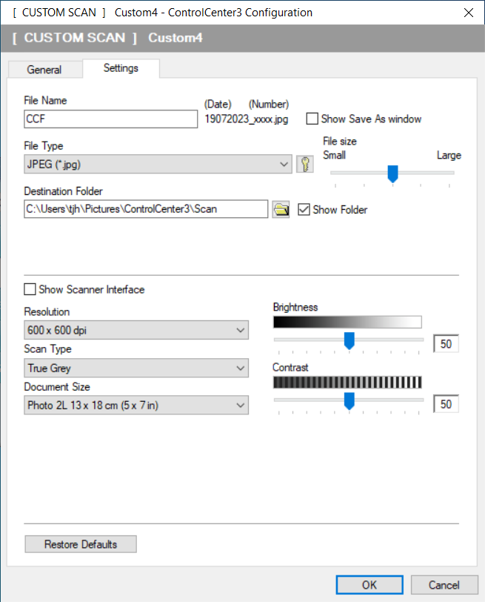

My gates photos are typically about 500K bytes.

Place prints in scanner long side parallel to long side of scanner glass. Scanned image will then **need rotating** by 90 degrees clockwise.

**Unexplained ( 28-JUL-23 ) observation**

Rotating and saving the scanned photo using **MS Photo** seems to produce a file that **is about half the size** of the same file rotated and saved using **MS Paint** !

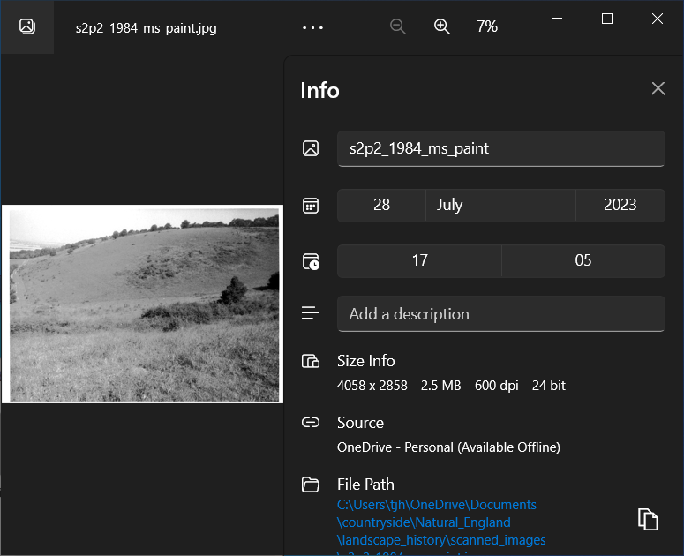

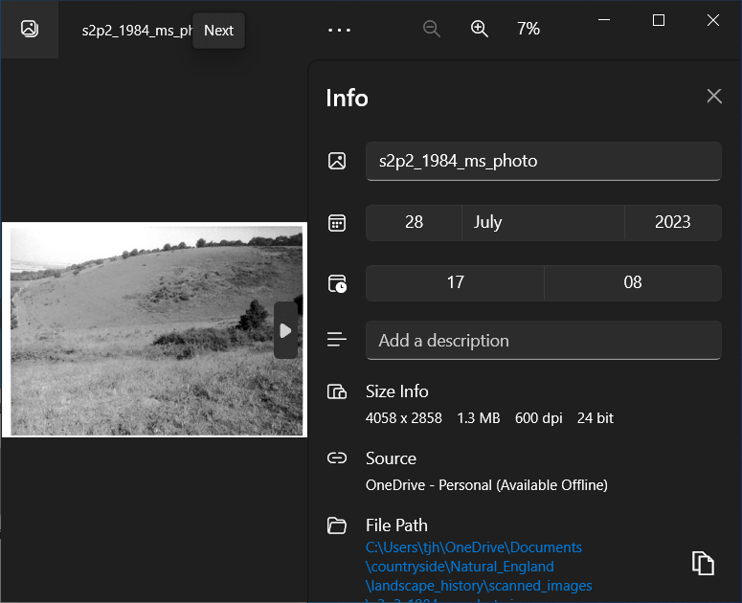

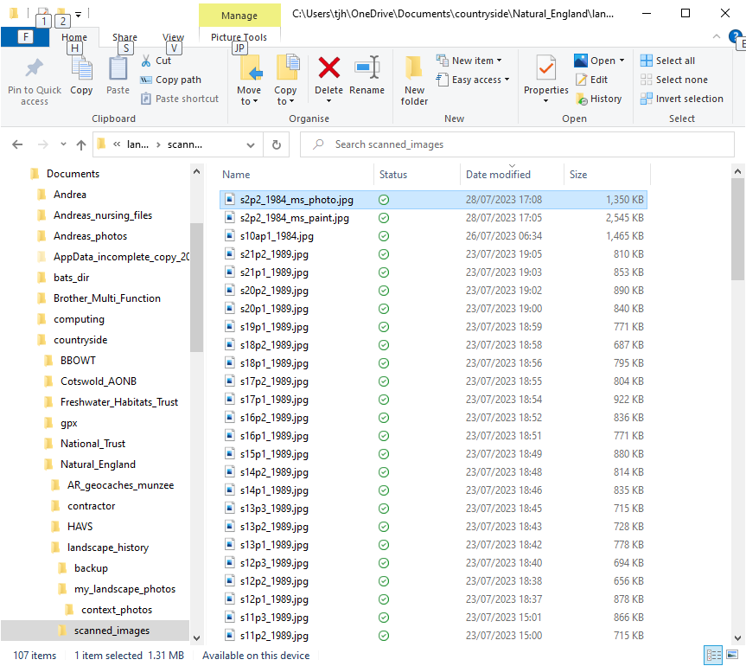

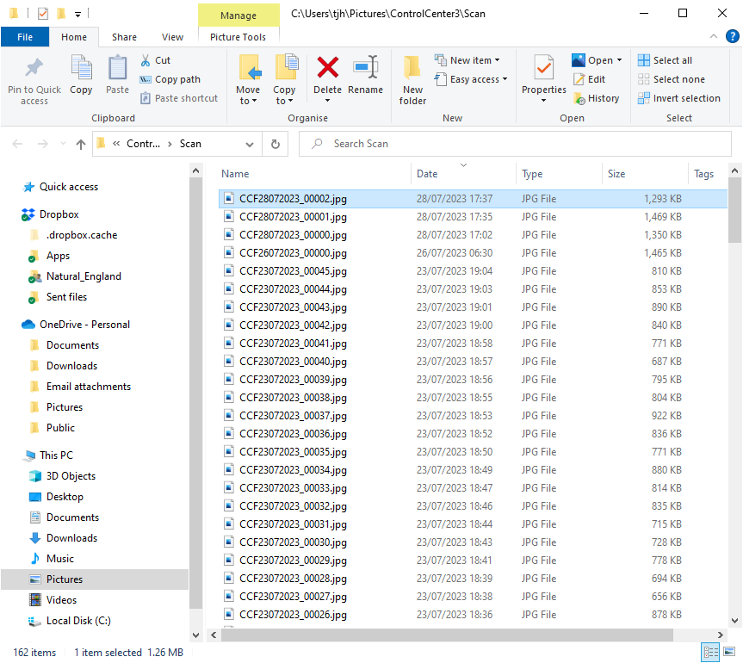

Also, I observe, that the use of MS Paint in this way **seems to increase the size** from that of the file from the scanner.

Default file opening application may be set via :-

Settings / Apps / "Default apps" / "Photo viewer".