prow_near_s14.docx

TJH 22-JUL-23

**Public Rights of Way near Aston Rowant NNR photo location "s14"**

"s14" is near grid 74300,96380 ( What3Words slot.sharpen.nightfall )

To get to s14 using Public Rights of Way as far as possible, leave the Christmas Common Road on Lewknor ( parish 277 ) path 19, leave that at its junction with path21. Follow path 21 to the county boundary and follow Stokenchurch ( parish STC ) path 1 section 2 and then turn left almost back on yourself onto section 3. After following STC/1/3 for approximately 100 m leave the PRoW to navigate to "s14".

<https://publicrightsofway.oxfordshire.gov.uk/StandardMap.aspx>

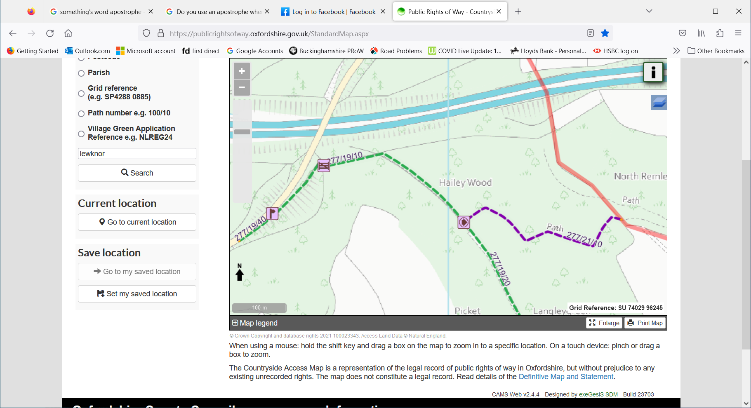

<https://prow.buckscc.gov.uk/standardmap.aspx>

